**Download Cisco Packet Tracer from:**

[**https://www.computernetworkingnotes.com/ccna-study-guide/download-packet-tracer-for-windows-and-linux.html**](https://www.computernetworkingnotes.com/ccna-study-guide/download-packet-tracer-for-windows-and-linux.html)

**Step by Step procedure to Install Cisco Packet tracer on Windows PC –**

**STEP 1 –**

After **Cisco Packet Tracer download**, click on the downloaded exe file. Once below Window will appear, click the “Next” option –

[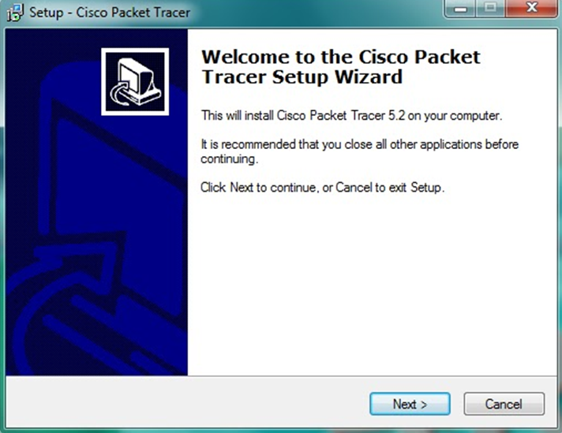](http://ipwithease.com/how-to-install-packet-tracer-on-windows-system/171how-to-install-packet-tracer-on-windows-system-01/)

Step 1 of install packet tracer after packet tracer download

**STEP 2 –**

On the next screen, select “I accept the agreement” and click on “Next”.

[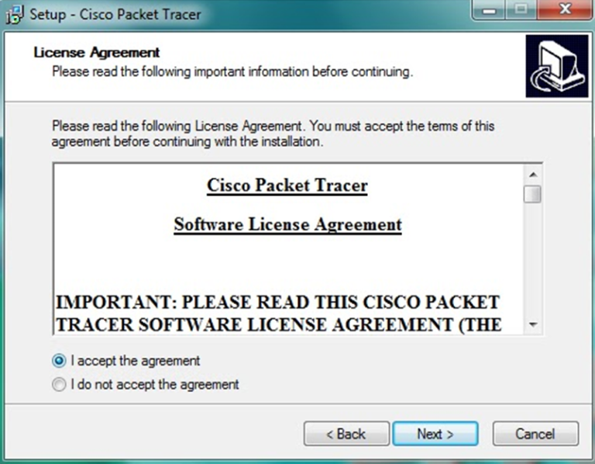](http://ipwithease.com/how-to-install-packet-tracer-on-windows-system/171how-to-install-packet-tracer-on-windows-system-02/)

Step 2 of install packet tracer

**STEP 3 –**

[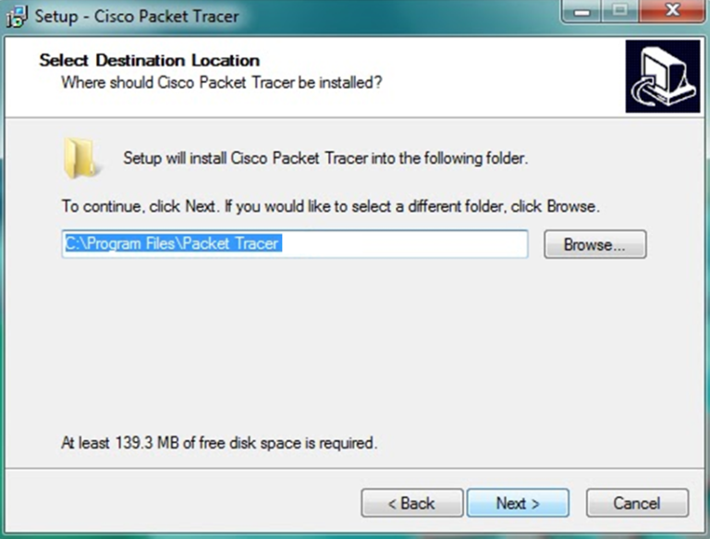](http://ipwithease.com/how-to-install-packet-tracer-on-windows-system/171how-to-install-packet-tracer-on-windows-system-03/)

Step 3 of installing packet tracer

Setup will show the folder in which the program’s shortcuts will be created. If you want to change the folder, you can change it. Click on “Next”.

**STEP 4 –**

[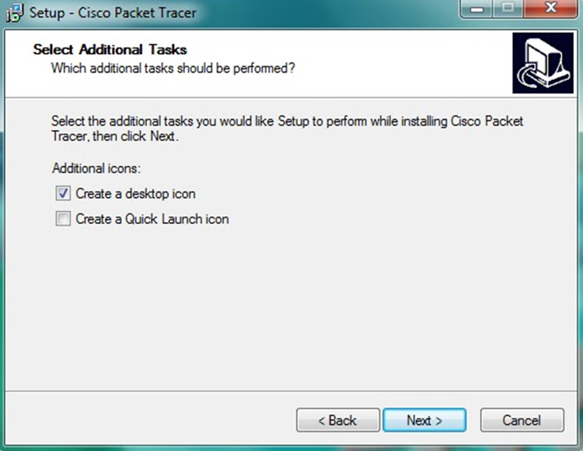](http://ipwithease.com/how-to-install-packet-tracer-on-windows-system/171how-to-install-packet-tracer-on-windows-system-04/)

Step 4 of installing packet tracer

Then the program will ask whether to create a Desktop icon and create a Quick Launch icon. Make your choice and click on “Next”.

**STEP 5 –**

[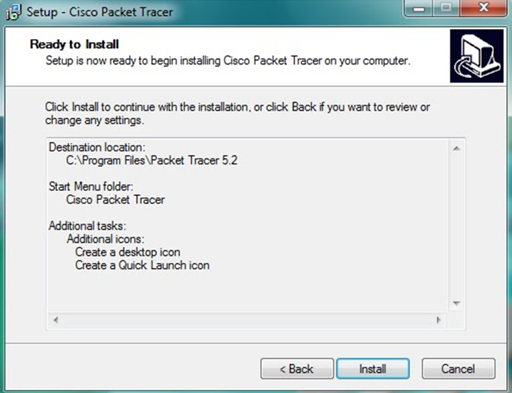](http://ipwithease.com/how-to-install-packet-tracer-on-windows-system/171how-to-install-packet-tracer-on-windows-system-05/)

Step 5 of installing packet tracer

The summary of the settings we selected is displayed. Click on *“Install”*.

**STEP 6 –**

The cisco packet tracer installation starts as shown below.[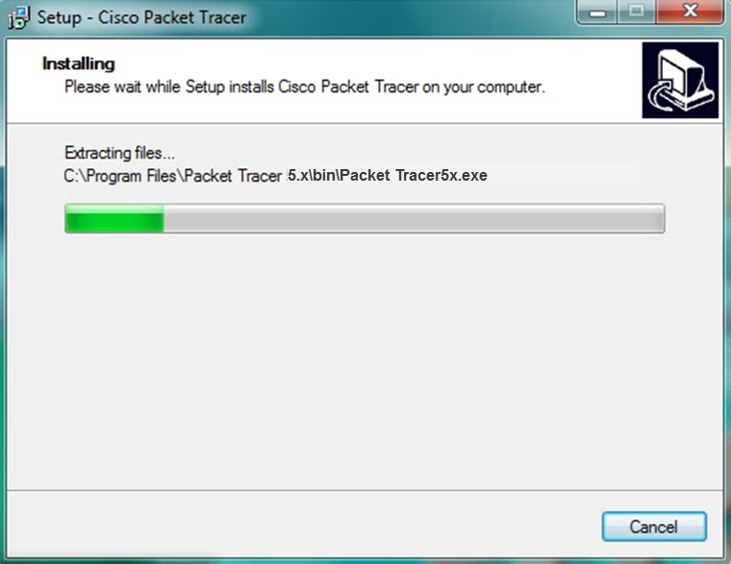](http://ipwithease.com/how-to-install-packet-tracer-on-windows-system/171how-to-install-packet-tracer-on-windows-system-06/)

**STEP 7 –**

Cisco packet tracer Installation gets completed and the below screen is shown. Click on “Finish”.

Click “OK” on next popup asking you to close or restart your computer.[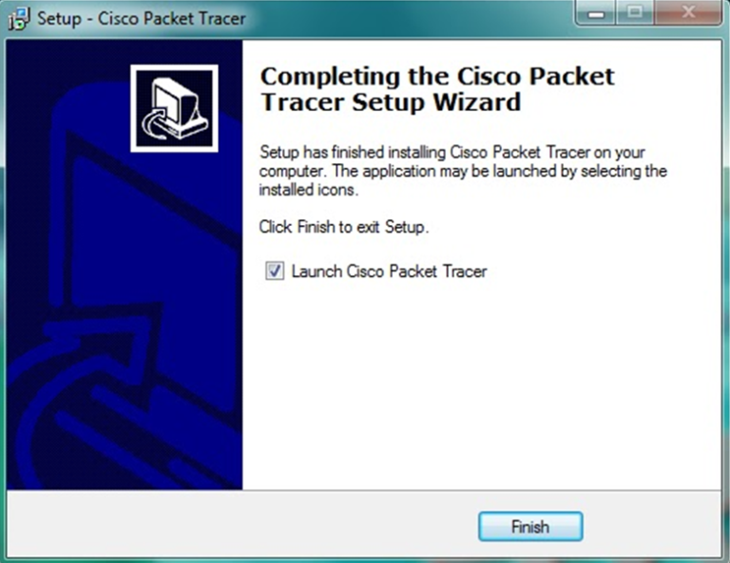](http://ipwithease.com/how-to-install-packet-tracer-on-windows-system/171how-to-install-packet-tracer-on-windows-system-07/)

**STEP 8 –**

Packet Tracer is installed and ready to be used.

**Note –** new updates, features and bug resolved versions of packet tracer is introduced on regular time intervals.

This was the entire process of cisco packet tracer download and install in windows.